Practical 1

Q1) Write a program in angular js to initialize the number and calculate the cube of the number.

Ans:

p1.1_num_cube.html

<!--

p1.1_num_cube.html

Author: Jagrut gala

Date: 29-06-2021

Practical: 1

Objective: Write a program in angular js to initialize the number and calculate the cube of the number.

-->

<!DOCTYPE html>

<html lang="en">

<head>

<meta charset="UTF-8">

<meta http-equiv="X-UA-Compatible" content="IE=edge">

<meta name="viewport" content="width=device-width, initial-scale=1.0">

<title>Document</title>

<script src="..\angular.min.js"></script>

</head>

<body>

<div class="root" ng-app="">

<div ng-init="num1= 5">

<p>Cube of {{num1}} is {{num1* num1* num1}}</p>

</div>

</div>

</body>

</html>



Q2) Write a program in angular js to initialize the array with the object. The Object consists of venue and country. Display All the values of the array in the unordered list.

Ans:

p1.2_venue_country.html

<!--

p1.2_venue_country.html

Author: Jagrut Gala

Date: 29-06-2021

Practical: 1

Objective: Write a program in angular js to initialize the array with the object. The Object consists of venue and country. Display All the values of the array in the unordered list.

-->

<!DOCTYPE html>

<html lang="en">

<head>

<meta charset="UTF-8">

<meta http-equiv="X-UA-Compatible" content="IE=edge">

<meta name="viewport" content="width=device-width, initial-scale=1.0">

<title>Document</title>

<script src="..\angular.min.js"></script>

</head>

<body>

<div class="root" ng-app="">

<div ng-init="places_countries=[

{venue:'Mulund',country:'India'},

{venue:'New York',country:'USA'},

{venue:'Toronta',country:'Canada'},

]">

<ul>

<li ng-repeat="i in places_countries">

{{i.venue+ ' is from '+ i.country}}

</li>

</ul>

</div>

</div>

</body>

</html>



Q3) Write a program in angular js to accept the first name from the user and display a welcome username message using ng-bind.

Ans:

p1.3_greet_user.html

<!--

p1.3_greet_user.html

Author: Jagrut Gala

Date: 29-06-2021

Practical: 1

Objective: Write a program in angular js to accept the first name from the user and display a welcome username message using ng-bind.

-->

<!DOCTYPE html>

<html lang="en">

<head>

<meta charset="UTF-8">

<meta http-equiv="X-UA-Compatible" content="IE=edge">

<meta name="viewport" content="width=device-width, initial-scale=1.0">

<title>practical_1.1</title>

<script src="..\angular.min.js"></script>

<style>

b {

color: red;

}

</style>

</head>

<body>

<div class="root" ng-app="">

<label for="fname">Enter First Name: </label> <input type="text" id="fname" ng-model="name"> <br> <br>

<p>Welcome <b ng-bind="name"></b></p>

</div>

</body>

</html>

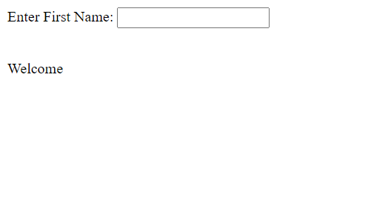

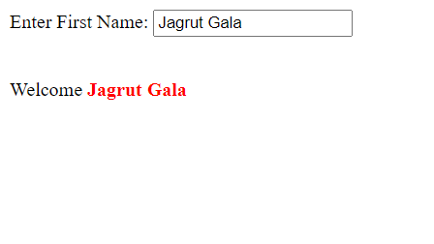

Q4) Demonstrate the use of ng-show and ng-hide directives.

Ans:

p1.4_show_hide.html

<!--

p1.4_show_hide.html

Author: Jagrut Gala

Date: 29-06-2021

Practical: 1

Objective: Demonstrate the use of ng-show and ng-hide directives.

-->

<!DOCTYPE html>

<html lang="en">

<head>

<meta charset="UTF-8">

<meta http-equiv="X-UA-Compatible" content="IE=edge">

<meta name="viewport" content="width=device-width, initial-scale=1.0">

<title>Document</title>

<script src="..\angular.min.js"></script>

</head>

<body>

<div class="root" ng-app="">

<div>

<label for="show-h">Show HTML</label> <input type="checkbox" ng-model="show_html">

<h1 ng-show="show_html">Welcome</h1>

</div>

<div>

<label for="show-h">Hide HTML</label> <input type="checkbox" ng-model="hide_html">

<h1 ng-hide="hide_html">Welcome</h1>

</div>

</div>

</body>

</html>

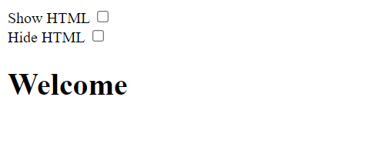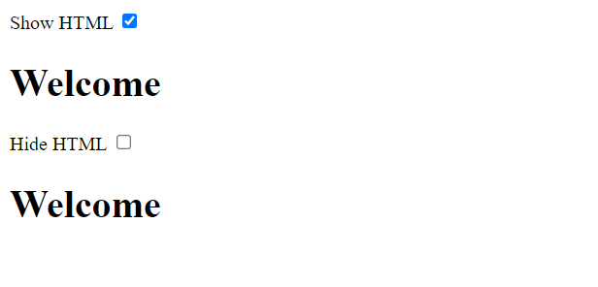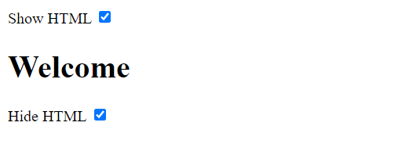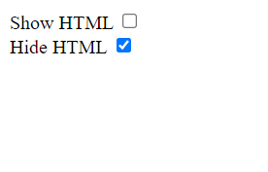

Q5) Write a program in angular js to display a table of sports with the column sports name, the total number of likes, and a total number of dislike and like and dislike buttons on the click of like button its should increment the number of like or dislike. Initialize the table data in the js file.

Ans:

p1.5_like_dislike.html

<!--

p1.5_like_dislike.html

Author: Jagrut Gala

Date: 29-06-2021

Practical: 1

Objective: Write a program in angular js to display a table of sports with the column sports name,

the total number of likes and total number of dislike and like and dislike button on click of like button its should increment the number of like or dislike.

Initialize the table data in the js file.

-->

<!DOCTYPE html>

<html lang="en">

<head>

<meta charset="UTF-8">

<meta http-equiv="X-UA-Compatible" content="IE=edge">

<meta name="viewport" content="width=device-width, initial-scale=1.0">

<title>Document</title>

<script src="..\angular.min.js"></script>

<style>

table, tr, td, th {

border: 1px solid black;

border-collapse: collapse;

}

td, th {

padding: 1rem 2rem;

}

button {

padding: 0.5rem 1.5rem;

font-weight: bold;

}

</style>

</head>

<body>

<div class="root" ng-app="myapp">

<div ng-controller="sport_ctrl">

<table>

<tr>

<th>Sport</th>

<th>Likes</th>

<th>Dislikes</th>

<th></th>

<th></th>

</tr>

<tr ng-repeat="i in sports">

<td>{{i.name}}</td>

<td>{{i.like}}</td>

<td>{{i.dislike}}</td>

<td><button ng-click="like(i)">Like</button></td>

<td><button ng-click="dislike(i)">Disklike</button></td>

</tr>

</table>

</div>

</div>

<script>

var myapp= angular.module("myapp", []);

myapp.controller("sport_ctrl", function($scope){

$scope.sports= [

{name: 'Cricket', like: 0, dislike: 0},

{name: 'Football', like: 0, dislike: 0},

{name: 'Hockey', like: 0, dislike: 0},

{name: 'Tennis', like: 0, dislike: 0},

{name: 'E-Sport', like: 0, dislike: 0},

];

$scope.like= function(sport){

// console.log('Like');

sport.like++;

}

$scope.dislike= function(sport) {

// console.log('Dislike');

sport.dislike++;

}

});

</script>

</body>

</html>

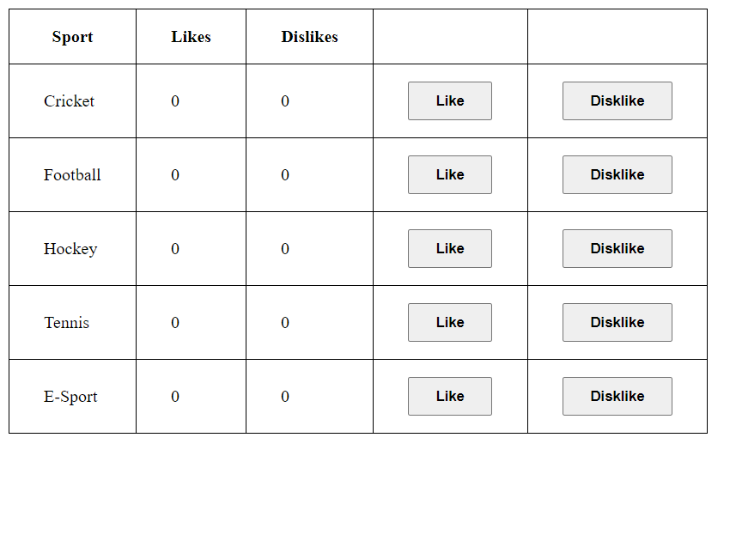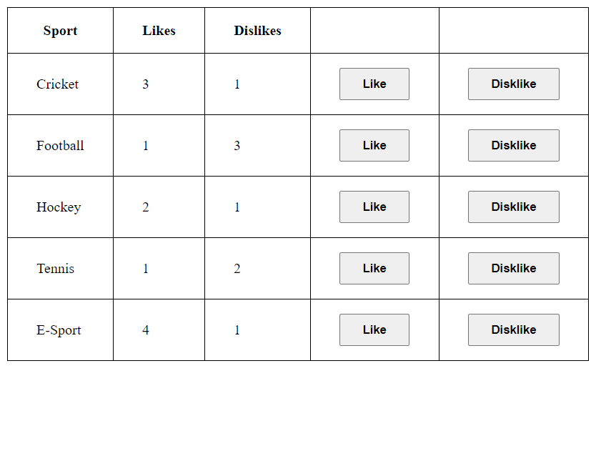

Practical 2

Q1)

Ans:

Q2)

Ans:

Q3)

Ans:

Practical 3

Q1) WAP in angular js to accept first name, salary per day and total number of working days, display first name with upper-case filter and the total salary(salary per day*total no. of working days) use currency filter (don’t use ng-click)

Ans:

p3.1_emp_salary.html

<!--

p3.1_emp_salary.html

Author: Jagrut Gala

Date: 13-07-2021

Practical: 3

Objective: WAP in angular js to accept first name, salary per day and total number of working days, display first name with upper case filter and the total salary(salary per day*total no. of working days) use currency filter (don’t use ng-click)

-->

<!DOCTYPE html>

<html lang="en">

<head>

<meta charset="UTF-8">

<meta http-equiv="X-UA-Compatible" content="IE=edge">

<meta name="viewport" content="width=device-width, initial-scale=1.0">

<title>Document</title>

<script src="..\angular.min.js"></script>

<style>

label {

margin-right: 1rem;

}

section {

margin: 0.5rem 0;

}

</style>

</head>

<body>

<div class="root" ng-app="">

<div>

<section>

<label for="name">Enter Your Name</label>

<input type="text" id="name" ng-model="name">

</section>

<section>

<label for="sal_day">Salary Per Day</label>

<input type="number" id="sal_day" ng-model="sal_day">

</section>

<section>

<label for="work_days">Number of Working Days</label>

<input type="number" id="work_days" ng-model="work_days">

</section>

<p>{{name| uppercase}} : {{(sal_day* work_days)| currency :'₹'}}</p>

</div>

</div>

</body>

</html>

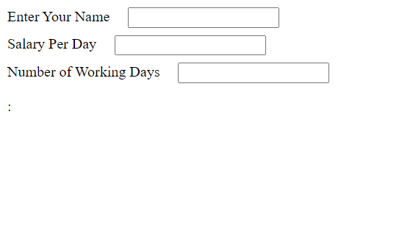

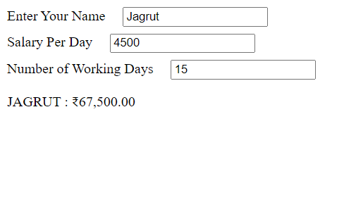

Q2) WAP in angular js to display the programming language in the ascending order and descending order using filter. Initialize the data in js file.

Ans:

p3.2_ascend_decend_lang.html

<!--

p3.2_ascend_decend_lang.html

Author: Jagrut Gala

Date: 13-07-2021

Practical: 3

Objective: WAP in angular js to display the programming language in the ascending order and descending order using filter. Initialize the data in js file.

-->

<!DOCTYPE html>

<html lang="en">

<head>

<meta charset="UTF-8">

<meta http-equiv="X-UA-Compatible" content="IE=edge">

<meta name="viewport" content="width=device-width, initial-scale=1.0">

<title>Document</title>

<script src="..\angular.min.js"></script>

<style>

.root {

display: flex;

}

.columns {

margin-right: 4rem;

}

</style>

</head>

<body>

<div class="root" ng-app="myapp" ng-controller="lang_ctrl">

<section class="columns">

<h1>Ascending</h1>

<ul>

<li ng-repeat="i in languages| orderBy: 'tut'">{{i.tut}}</li>

</ul>

</section class="columns">

<section>

<h1>Descending</h1>

<ul>

<li ng-repeat="i in languages| orderBy: '-tut'">{{i.tut}}</li>

</ul>

</section>

</div>

<script>

myapp = angular.module("myapp", []);

myapp.controller("lang_ctrl", function ($scope) {

$scope.languages = [

{"tut": "HTML"},

{"tut": "Python"},

{"tut": "Java"},

{"tut": "Android"},

{"tut": "CSS"},

{"tut": "AngularJS"},

{"tut": "ReactJs"}

];

});

</script>

</body>

</html>

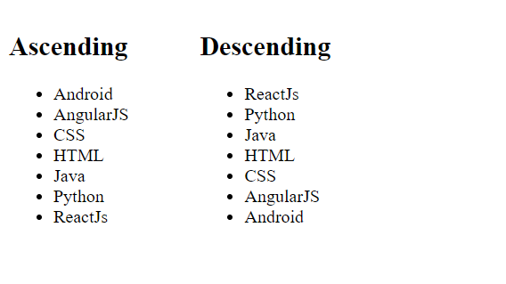

Q3) Using angularjs display the student details who are live in pune in table format (using ng-repeat directive ,use array to store data , use filter)

Ans:

p3.3_filter_student_table.html

<!--

p3.3_filter_student_table.html

Author: Jagrut Gala

Date: 13-07-2021

Practical: 3

Objective: Using angularjs display the student details who are live in pune in table format (using ng-repeat directive ,use array to store data , use filter)

-->

<!DOCTYPE html>

<html lang="en">

<head>

<meta charset="UTF-8">

<meta http-equiv="X-UA-Compatible" content="IE=edge">

<meta name="viewport" content="width=device-width, initial-scale=1.0">

<title>Document</title>

<script src="..\angular.min.js"></script>

<style>

table, tr, td,th {

border: 1px solid black;

border-collapse: collapse;

padding: 0.1rem 0.2rem;

}

.tables {

display: flex;

flex-direction: row;

}

.tables> * {

margin: 1rem;

}

</style>

</head>

<body>

<div class="root" ng-app="myapp">

<div ng-controller="student_ctrl">

<div class="tables">

<table>

<tr>

<th>Name</th>

<th>City</th>

</tr>

<tr ng-repeat="i in stud">

<td>{{i.name}}</td>

<td>{{i.city}}</td>

</tr>

</table>

<table>

<tr>

<th>Name</th>

<th>City</th>

</tr>

<tr ng-repeat="i in stud | filter: fill">

<td>{{i.name}}</td>

<td>{{i.city}}</td>

</tr>

</table>

</div>

<button type="button" ng-click="apply_filter('pune')">Apply Filter</button>

<button type="button" ng-click="apply_filter('')">Remove Filter</button>

</div>

</div>

<script>

myapp= angular.module("myapp", []);

myapp.controller("student_ctrl", function($scope){

$scope.stud = [

{ name: 'Amit', city: 'pune' },

{ name: 'Sumit', city: 'pune' },

{ name: 'Rahul', city: 'mumbai' },

{ name: 'sachin', city: 'mumbai' },

];

$scope.fill= "";

$scope.apply_filter= function(f){

$scope.fill= f;

}

});

</script>

</body>

</html>

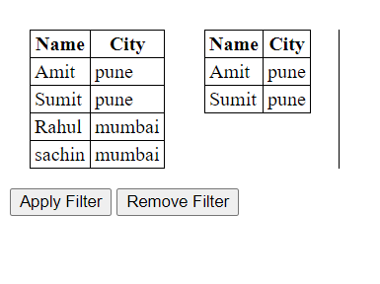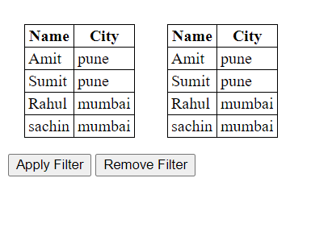

Practical 4

Q1) WAP in angular js to display tables with the column name id , title, author and price. Initialize the table data in js file . Create a dropdown menu with the option any, Id , title, author and price and a search input box. On selection of the dropdown and value entered in the input search box it should display the data into the table.

Ans:

p4.1_book_full_filter.html

<!--

p4.1_book_full_filter.html

Author: Jagrut Gala

Date: 13-07-2021

Practical: 4

Objective: WAP in angular js to display table with the column name id , title, author and price. Initialize the table data in js file . Create a dropdown menu with the option any, Id , title, author and price and a serach input box. On selection of the dropdown and value entered in the input search box it should display the data into the table.

-->

<!DOCTYPE html>

<html lang="en">

<head>

<meta charset="UTF-8">

<meta http-equiv="X-UA-Compatible" content="IE=edge">

<meta name="viewport" content="width=device-width, initial-scale=1.0">

<title>Document</title>

<script src="..\angular.min.js"></script>

<style>

tr, td, th {

border: 1px solid black;

border-collapse: collapse;

}

td, th {

padding: 0.2rem 0.4rem;

}

table {

box-sizing: border-box;

width: max-content;

margin: 1rem 0rem;

}

.books {

margin: auto;

}

</style>

</head>

<body>

<div class="root" ng-app="myapp">

<div ng-controller="book_ctrl">

<div class="tools">

<select name="search_select" id="search_select" ng-model="searchKeyword">

<option value="$">Any</option>

<option value="id">ID</option>

<option value="title">Title</option>

<option value="price">Price</option>

</select>

<input type="text" name="search_text" id="search_text" ng-model="search[searchKeyword]">

</div>

<div class="books">

<table>

<tr>

<th>ID</th>

<th>Title</th>

<th>Price</th>

</tr>

<tr ng-repeat="i in bookList | filter: search">

<td>{{i.id}}</td>

<td>{{i.title}}</td>

<td>{{i.price}}</td>

</tr>

</table>

</div>

</div>

</div>

<script>

myapp= angular.module("myapp", []);

myapp.controller("book_ctrl", function($scope){

$scope.search= {}

$scope.searchKeyword= "$";

$scope.bookList = [

{ "id": 1, "title": "Hobbit", "author": "Aman", "price": 700 },

{ "id": 2, "title": "Lord of the rings", "author": "Sameer", "price": 1000 },

{ "id": 3, "title": "Harry Porter", "author": "Anuj", "price": 650 },

{ "id": 4, "title": "The little prince", "author": "Jatin", "price": 870 },

{ "id": 5, "title": "Angels and Demons", "author": "Shivam", "price": 890 }

];

});

</script>

</body>

</html>

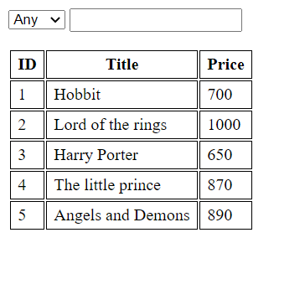

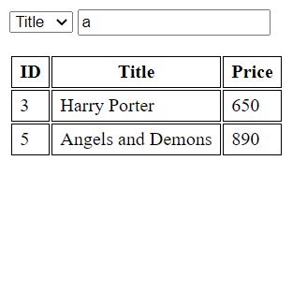

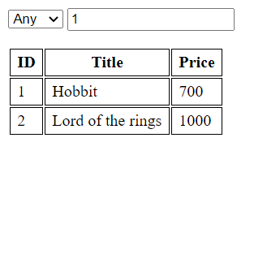

Q2) WAP in angularjs to initialize the data of employee(id,name,and salary) atleast 5 records. And use limit to filter to display first 3 record

Ans:

p4.2_emp_limitto.html

<!--

p4.2_emp_limitto.html

Author: Jagrut Gala

Date: 20-07-2021

Practical: 4

Objective: WAP in anularjs to initialize the data of employee(id,name,and salary) atleast 5 records. And use limit to filter to display first 3 record

-->

<!DOCTYPE html>

<html lang="en">

<head>

<meta charset="UTF-8">

<meta http-equiv="X-UA-Compatible" content="IE=edge">

<meta name="viewport" content="width=device-width, initial-scale=1.0">

<title>Document</title>

<script src="..\angular.min.js"></script>

<style>

table, tr, th, td {

border: 1px solid black;

border-collapse: collapse;

padding: 0.5rem 1rem;

}

table {

margin: 1rem;

}

</style>

</head>

<body>

<div class="root" ng-app="myapp" ng-controller="emp_ctrl">

<label for="srows">No of Rows shown</label> <input type="number" name="srows" id="srows" ng-model="total">

<table>

<tr>

<th>ID</th>

<th>Name</th>

<th>Salary</th>

</tr>

<tr ng-repeat="i in employees| limitTo: total">

<td>{{i.id}}</td>

<td>{{i.name}}</td>

<td>{{i.salary}}</td>

</tr>

</table>

</div>

<script>

myapp= angular.module("myapp", []);

myapp.controller("emp_ctrl", function($scope){

$scope.employees= [

{id: 1, name: "Lorem", salary: 20000},

{id: 2, name: "Ipsum", salary: 22000},

{id: 3, name: "Dolor ", salary: 25000},

{id: 4, name: "Amet", salary: 30000},

{id: 5, name: "Consectetur", salary: 15000},

{id: 6, name: "Lacus", salary: 35000},

{id: 7, name: "Metus", salary: 62000}

];

});

</script>

</body>

</html>

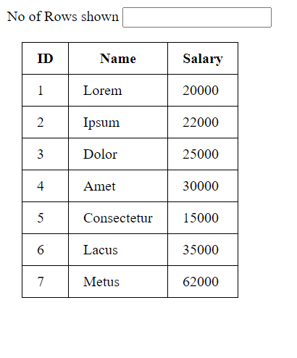

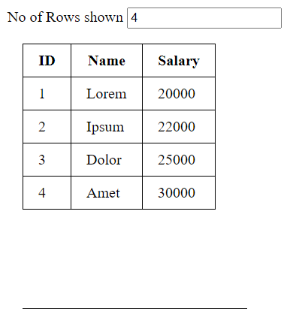

Q3) Demonstration of limit to filter using string and array.

Ans:

p4.3_string_limito.html

<!--

p4.3_string_limito.html

Author: Jagrut Gala

Date: 20-07-2021

Practical: 4

Objective: Demonstration of limit to filter using string and array.

-->

<!DOCTYPE html>

<html lang="en">

<head>

<meta charset="UTF-8">

<meta http-equiv="X-UA-Compatible" content="IE=edge">

<meta name="viewport" content="width=device-width, initial-scale=1.0">

<title>Document</title>

<script src="..\angular.min.js"></script>

</head>

<body>

<div class="root" ng-app="myapp" ng-controller="string_limit_ctrl">

<p>Static 5 Character Limit String ➞ <q >{{string | limitTo: 5}}</q></p>

<label for="string_len">No of Characters Displayed</label>

<input type="number" name="string_len" id="string_len" ng-model="slen">

<p>String ➞ {{dstring| limitTo: slen}}</p>

<label for="array_len">No of Words Displayed</label>

<input type="number" name="array_len" id="array_len" ng-model="alen">

<p>Array ➞ {{darray| limitTo: alen}}</p>

</div>

<script>

myapp= angular.module("myapp", []);

myapp.controller("string_limit_ctrl", function($scope){

$scope.string= "Pellentesque";

$scope.dstring= "Praesent vitae urna a metus ultricies elementum nec in leo";

$scope.darray= "Maecenas interdum purus nec dolor porttitor, in ornare quam aliquet".split(' ');

});

</script>

</body>

</html>

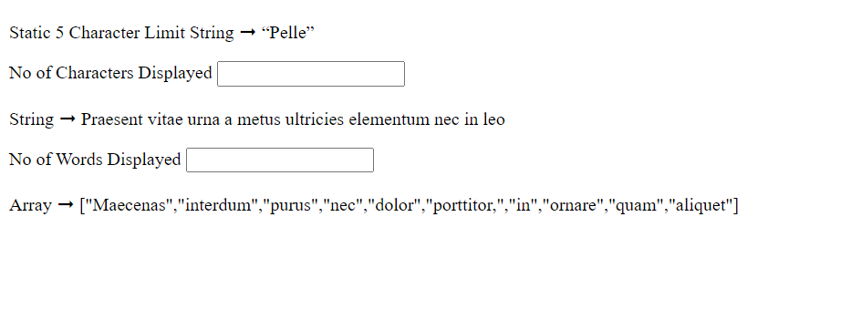

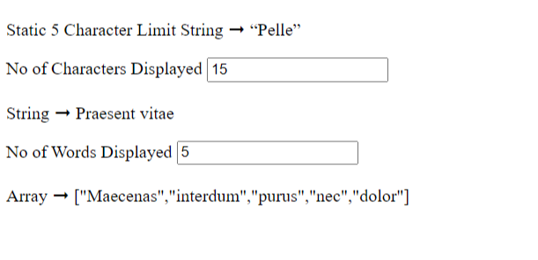

Q4) WAP in angularjs to initialize the data of employees. Create a custom filter to display a record of emp whose salary >5000.

Ans:

p4.4_emp_salary.html

<!--

p4.4_emp_salary.html

Author: Jagrut Gala

Date: 20-07-2021

Practical: 4

Objective: WAP in angularjs to initialize the data of employees. Create a custom filter to display a record of emp whose salary >5000.

-->

<!DOCTYPE html>

<html lang="en">

<head>

<meta charset="UTF-8">

<meta http-equiv="X-UA-Compatible" content="IE=edge">

<meta name="viewport" content="width=device-width, initial-scale=1.0">

<title>Document</title>

<script src="..\angular.min.js"></script>

<style>

table {

margin: 1rem;

border-collapse: collapse;

}

tr, th, td {

border: 1px solid black;

border-collapse: collapse;

padding: 0.5rem 1rem;

}

</style>

</head>

<body>

<div class="root" ng-app="myapp" ng-controller="sal_ctrl">

<label for="sal">Salary</label> <input type="number" name="sal" id="sal" ng-model="sal_limit">

<table>

<tr>

<th>ID</th>

<th>Name</th>

<th>Salary</th>

</tr>

<tr ng-repeat="i in employees| sal_filter: sal_limit">

<td>{{i.id}}</td>

<td>{{i.name}}</td>

<td>{{i.salary}}</td>

</tr>

</table>

</div>

<script>

myapp= angular.module("myapp", []);

myapp.filter("sal_filter", function() {

return function(sal, limit= 5000) {

let new_sal= new Array();

if(limit== null){

return sal;

}

for(let i=0; i<sal.length; i++){

if(sal[i].salary > limit) {

new_sal.push(sal[i]);

}

}

return new_sal;

}

});

myapp.controller("sal_ctrl", function($scope){

$scope.employees= [

{id: 1, name: "Lorem", salary: 1579},

{id: 2, name: "Ipsum", salary: 7312},

{id: 3, name: "Dolor ", salary: 1384},

{id: 4, name: "Amet", salary: 9877},

{id: 5, name: "Consectetur", salary: 3040},

{id: 6, name: "Lacus", salary: 4484},

{id: 7, name: "Metus", salary: 6043}

];

});

</script>

</body>

</html>

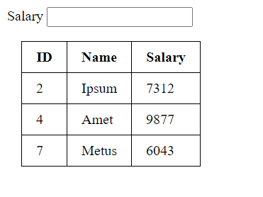

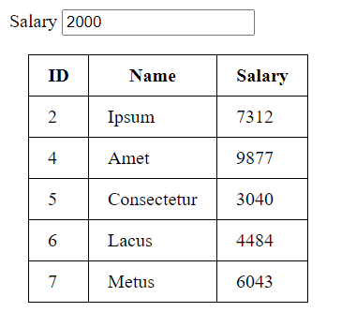

Practical 5

Q1) WAP in angular js to Use of ng-src. Create a food Menu List using ng-src. Create a table which displays food image, Menu Name and price.Display at least 5 Menu.

Ans: